THE TALLAND SCHOOL OF EQUITATION CHRISTMAS NEWSLETTER 2019
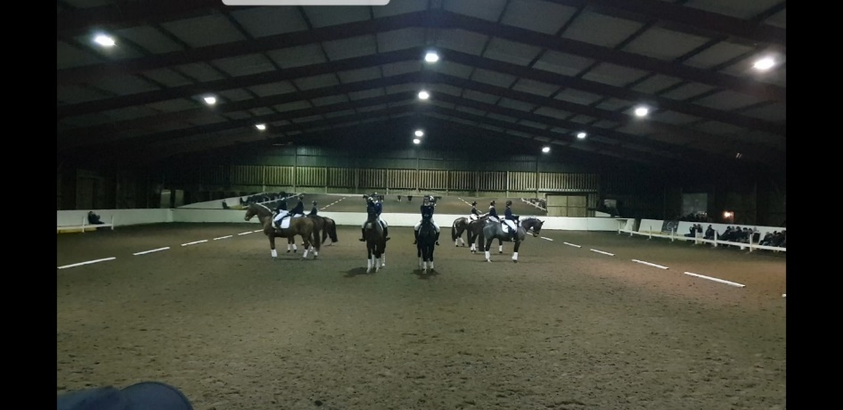

CLICK HERE
https://www.facebook.com/watch/?v=2548471661947084

This year we have posted the Student Demonstration ride at the top, as we are so proud of our 2019 group. We have had almost 100% pass rate with the new BHS Assessments leading to jobs both in this country and abroad. Michael Whippey runs our Assessment training and BHS Assessment days along with Claire Graves who runs our yard, who is the best ever.

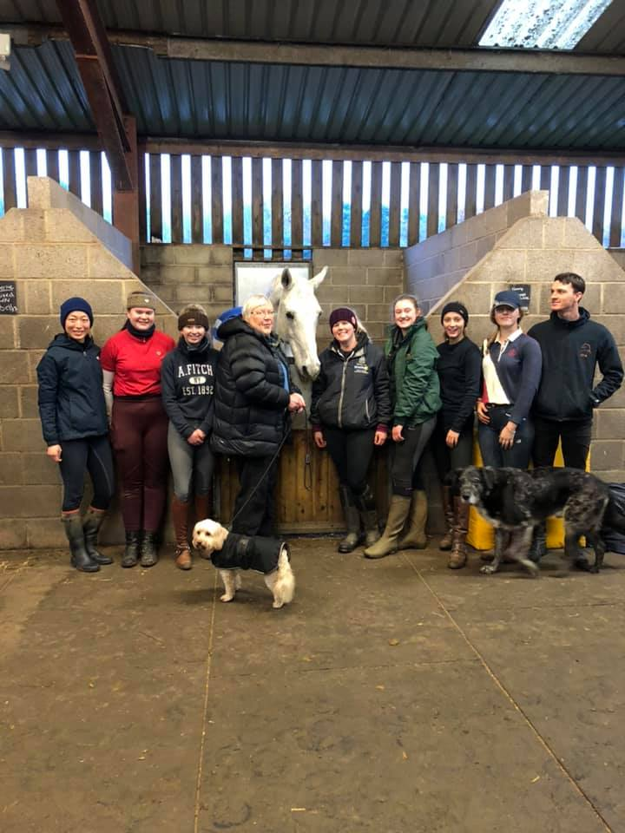

Special mention to all our school horses from Novice to Advanced and the cheeky ponies who also play a big part in the learning of younger clients at Talland. With our great variation of horses, we can offer tuition to everyone – from a child having their first ride to Olympic riders. Both on the flat and over fences. A mention to our special Tommy who has just gone home to retire. No need to worry as we have one or two trying to fill his boots. Sadly we have lost both Olly and Lucas to the great arena in the sky, Olly who had been part of the Talland team for many years and in his time he took both Charlie & Pippa up to Grand Prix international and taught many clients flying changes, piaffe and passage and LJT Lucas Normark who represented Great Britain with Anne Dunham at the Olympics and Europeans winning many gold and silver medals. They will both be greatly missed by everyone at Talland and all who had the pleasure of knowing and riding them.
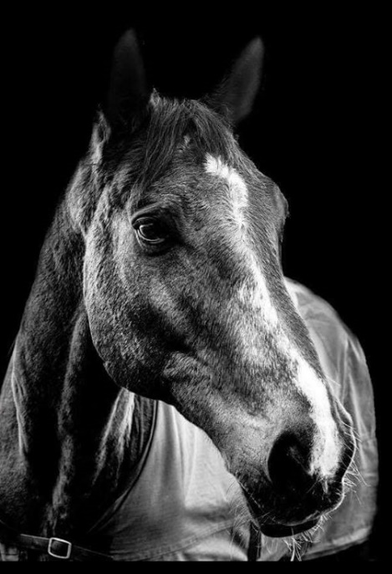
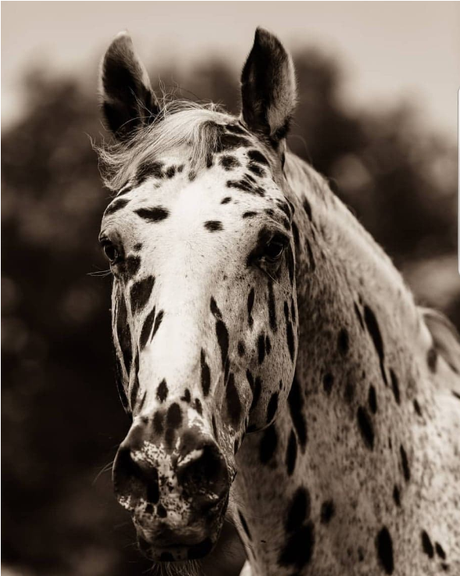

We could not be more pleased with our students this year, there have been successes in Eventing, Show Jumping and Dressage, Nationally and Internationally including Asia where Raunaq Anand was 4th in the under 21 Asian Games.
We have placements remaining for January 2020 - Come and join our team at Talland, we offer a variety of courses to suit the individual both short and long term. We will help you achieve your qualifications whilst competing for those that want to!
A highlight being the return of older students...from up to 60 years ago with discounts of course!
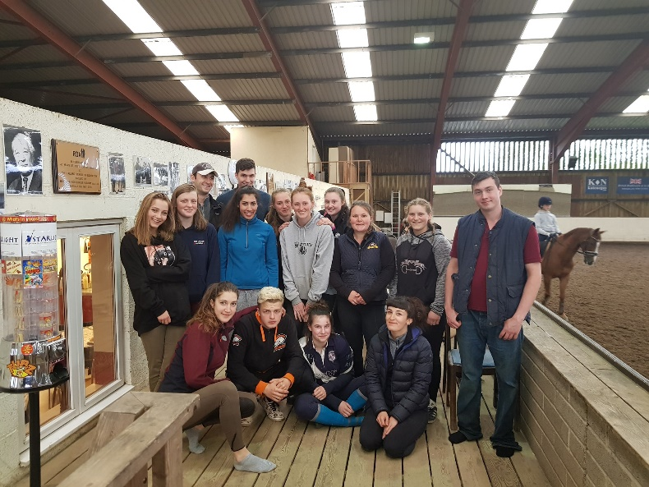

Talland could not run without the fabulous staff. From our stunning cooks Laura and Tracey; to Dave Trotman in charge of maintenance; Reception staff with the new addition Emma Scarlett; to teaching with all our instructors Richard, Hilary, Gerry, Mike, Marie, Claire, Toby, Emma, Britt, Raffi – all make up our excellent Talland teaching team. ; incorporating training students and schooling horses. Backing to hacking, dressage to cross county and everything in between. Part time filming has crept in for some led by Jenny Rudall; and the Talland dogs have become stars as well. We have filmed a series of All stars returns to Talland - one of the most popular programmes on Horse and Country TV, and we are booked for 2020. Buy the Horse and Country App for details and release dates.
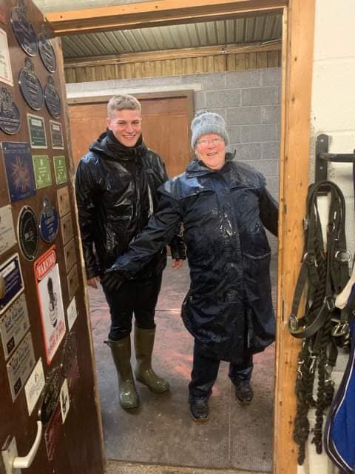

We have been very busy this year with our Holiday courses for the young and older, 3-day adult packages and residential courses. We offer 1 to 4-week courses throughout term time holidays and the summer for our younger clients. We have also met some lovely clients who have taken part in our 3-day riding packages this year – it helps that the local pub is within walking distance. We will be running several adult camps in the new year so keep an eye out for the dates.

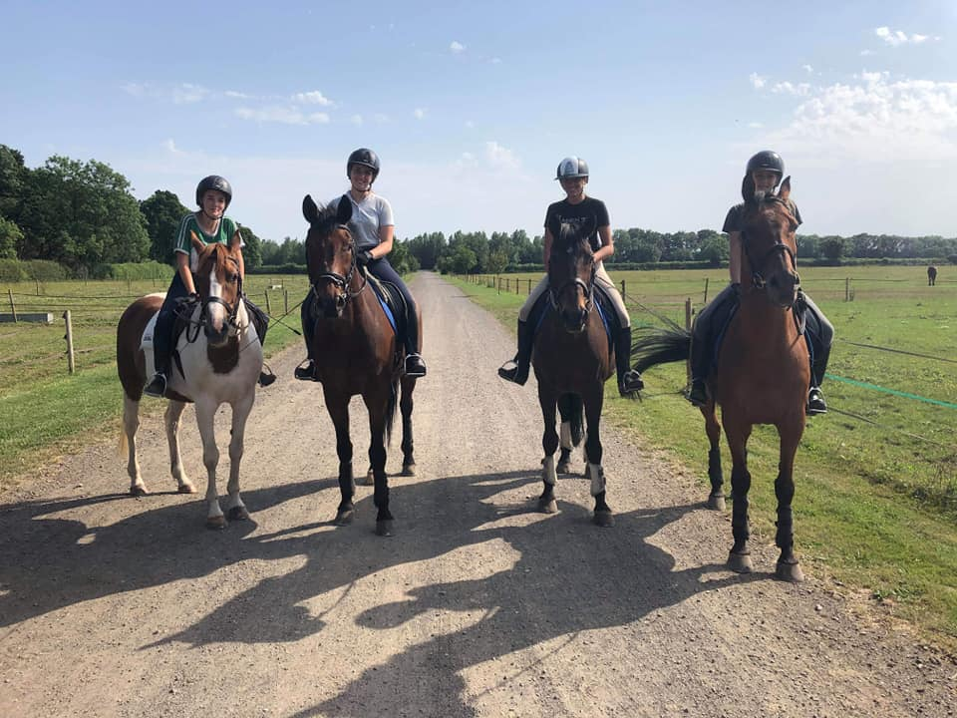

Our wonderful Liveries have their own block, which is run exceptionally well by Brittany Lankston, our liveries have the opportunity to ride late into the evening with our indoor school.
A special thank you to be made to Popa Katalin Kostel who leads the best team from Romania ever, who work hard each day to provide our horses with the best beds and general upkeep of Talland.

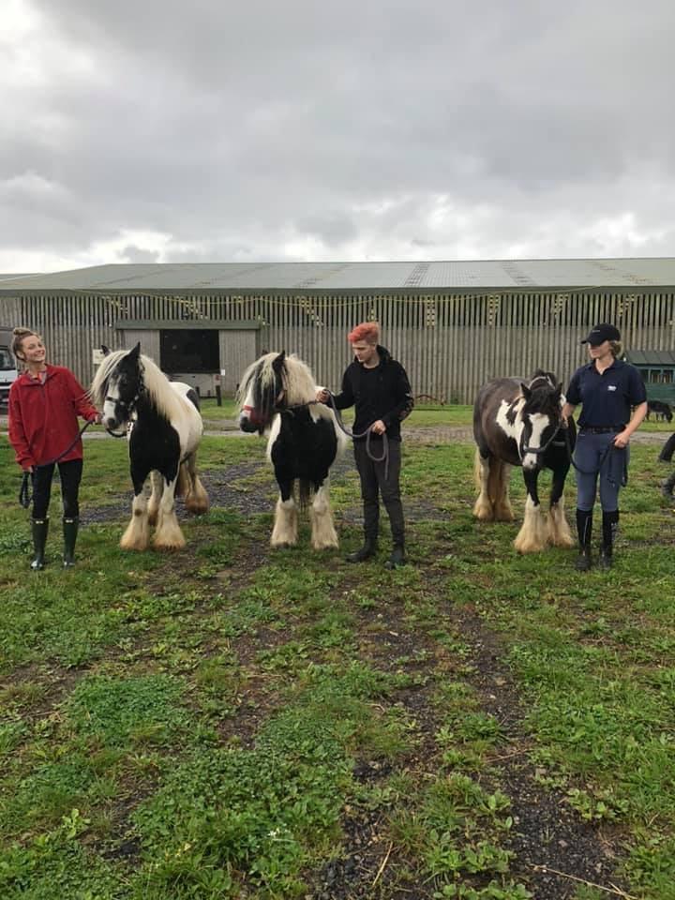

This year we are proud to announce the arrival of our 3 Coblets Annie, Daisy and Abigail they came to Talland through the BHS Second Chance rehoming project delivering a brighter future for horses who have suffered an unhappy past. All three have settled in well and even took part in our Christmas demo under saddle! We are very pleased with their progress and we are excited for the new year.
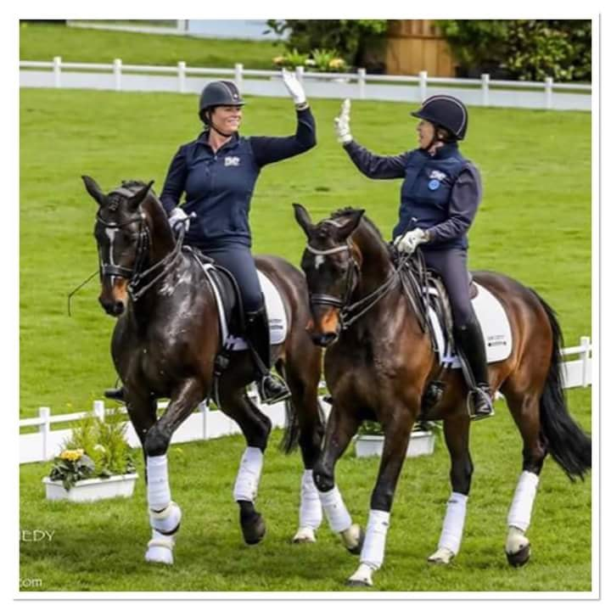

The family, with Brian as the glue have also been very busy.
Brian between teaching keeps the farm in order; and Charlie having used Talland as a base for 2019, moving on into 2020 will be in Scotland and commuting twice a month.

Pippa has now established her own corner of Talland and is looking forward to 2020 with several horses. Loving her teaching and pulling her Mum’s leg is a daily occurrence.
Pammy has done some resurrecting, the highlight being adding an International plaque onto her board 51 years after her first. She intends to make it 52! Combining clinics at Talland and away keeps her busy but make no mistake, none would happen without Brian!

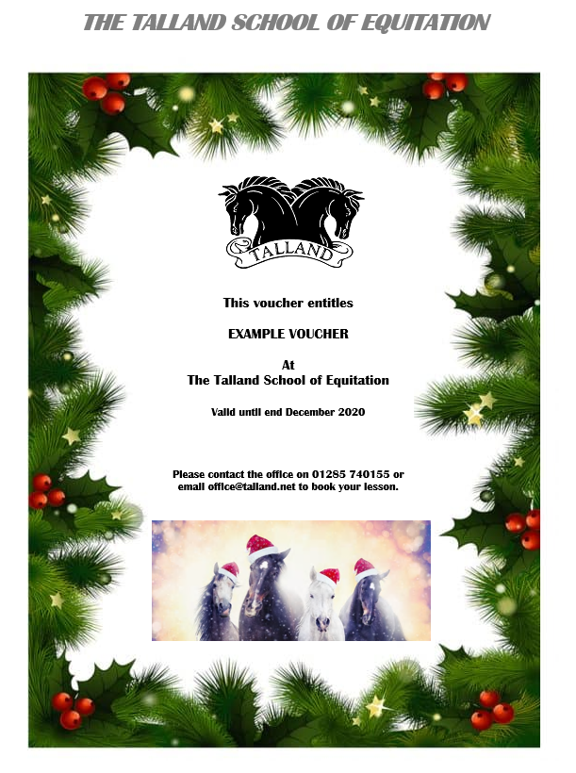
Give someone the perfect present for Christmas with one of our Gift Vouchers. Vouchers can be purchased online through our website or over the phone.

We are grateful for all cards received, and hope this newsletter keeps you all informed.
With very Best Wishes from The Talland Team and all the Hutton Family

