The Talland School of Equitation

2020 Christmas Newsletter

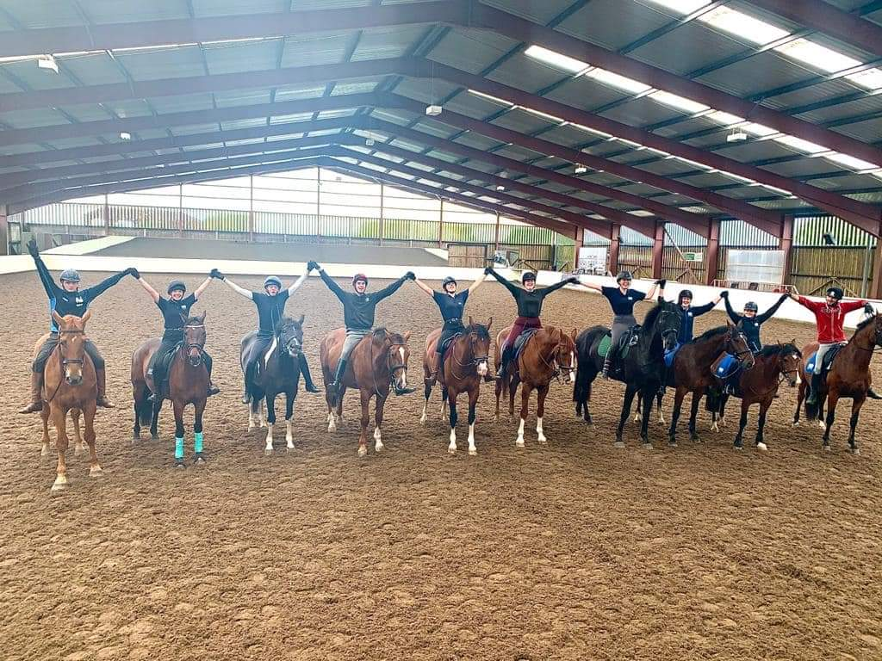

The abundance of a bad virus and a shortage of good forage and bedding sums up 2020. The latter we have experienced before, the former had the nation reeling.
Like most equestrians we simply had to get on and make the best of a bad job and thanks to our superb staff and students along with the exceedingly kind financial assistance from our loyal supporters, Just Giving, the BHS, the Government and Barclays Bank, we are still here!
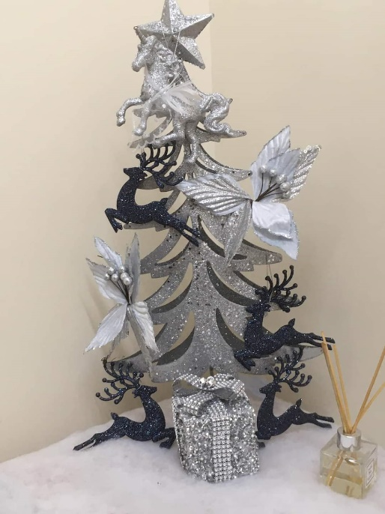

Maintaining order is Mandy’s specialty and she uses her vast experience with quiet authority. We are lucky to have her looking after our precarious finances so well and we are always grateful for Stephen Days consistent help over many years.
Currently Hilary is not here as she is on her annual holiday following her stalwart stint between lockdowns and Marie is a great asset when she comes in. We miss Gerry who has retired from full time teaching but luckily, he plans to come in part time in 2021. We lost Richard from our teaching staff as he has rescheduled his life more around his family and Michael Whippey has moved on to pursue his individual aims.
“We aim to please” seems to be the motto for Claire and Britt who tirelessly oversee the stables, teach, run countless assessments and deal with the multitudinal events that occur in a large busy yard.
Emma and Amber man a remarkably busy office with occasional help from Clair, Megan and Natalie who helps so much with our younger clients. As you can imagine the amount of red tape and admin is immense but somehow order is maintained. Emma also manages to teach Side Saddle throughout the week. Emma’s daughter Zara also joins us once a week to come and ride.
Laura and Tracey look after everyone’s appetites in the café – no easy task when catering for so many gastronomic needs.
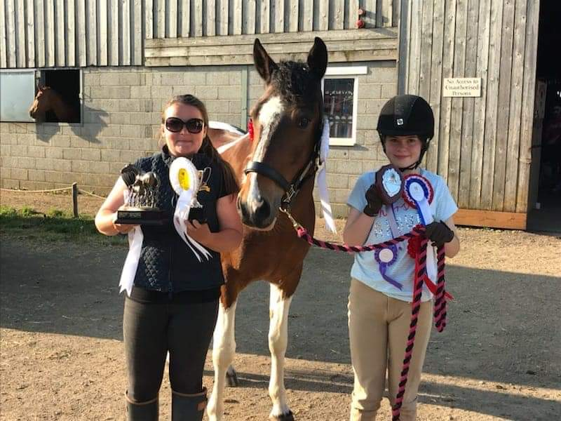
Catalin, Georgie and Andre work hard mucking out and helping around the yard including painting the new show jumps etc, and Kathryn works hard keeping Talland clean and Tidy.

Brittany Lankston, Isabella Benfield and Cookie
It has been a quiet year on livery row, but a year for all owners to get to know their horse. A few competitions did go ahead with Isabella and her pony Cookie competing in Para & affiliated Dressage. Clair Reed & Dori doing some elementary tests and Ellen and Faith taking on some showjumping with Biscuit and Mickey. Elspeth Von Sponeck winning her class and collecting her first Blue Chip Ticket. We have also welcomed a few new faces this year including CobDoplphin, Ayla, Mickey, and Shadow.
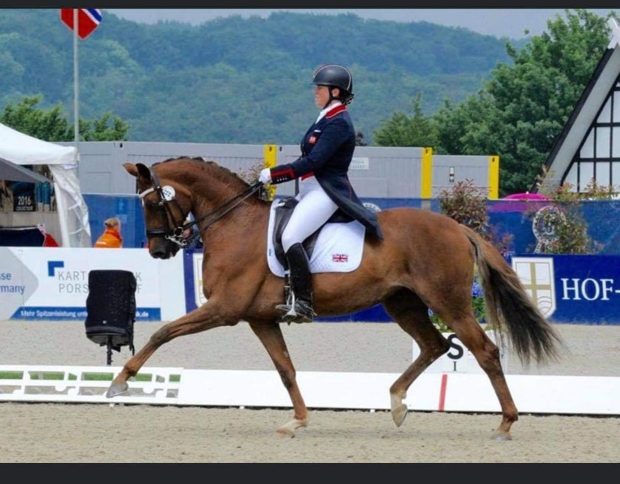

Pippa Hutton & Duela
Pippa is an increasing help to the business and passed her BHSI Riding and Coaching which is a great boost to her professional life, and she appears settled in her personal life with boyfriend Adam who helps with his teaching and culinary skills.
Pippa has quoted
“2020 has been a rollercoaster of a ride. With all that has gone on I feel the Talland team is stronger than ever. We have really pulled together as a team this year. I could not have done without the great support of my staff. This year I got some competitions under my belt and competed from Novice up to Inter 1 very successfully. I also took my BHSI equitation and coaching exam and passed! Each day I am learning the ropes of running a business and look forward to taking over the reins more and more each day. I love working alongside my Mother and Father. I have some huge boots to fill but learning from the best this should not be a problem.”
Charlie is based near Troon in Scotland; he is incredibly happy with Sandy and her 6yo daughter Lucy. He does a brilliant job for the BEF Podium Potential Pathway programme for the AASE Mentor for BD Academy and quite a few young horses to bring on for 2021. Roll on the Summer.
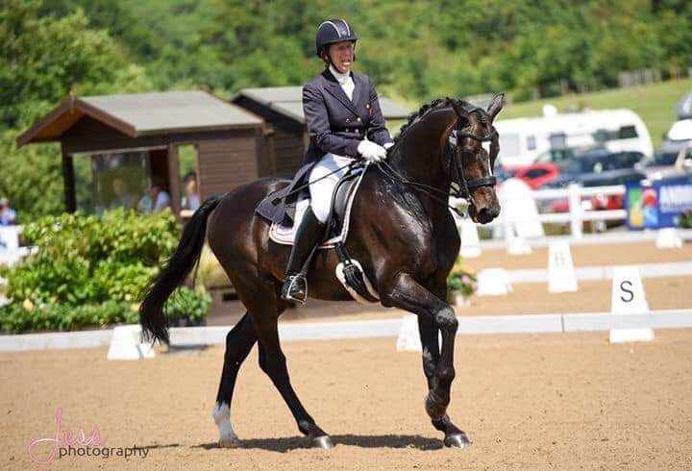

Pammy Hutton and Magnum
Pammy, despite her crippling back injury, has ridden with tremendous enthusiasm and success this year and has worked so hard to keep the business going and still found time to wite “Horses for life” with Islay Auty, which is selling fast and is still available to purchase from the office.
Brian takes great pleasure in helping so many riders, particularly the students during lockdown, with their work on the flat, over show jumps and with their cross-country training. He enjoys helping Charlotte Alexander with ex Race Horse Saphir Du Rheu. Having become a good hunter and an ace team chaser Charlotte is aiming to event him next year.
Brian also helps Jenny Rudall who keeps Finn with us and now that she has done her maternity stint and when not in demand as “The Queen of the microphone” it is hoped they will be back competing very soon. Huge thanks to Jenny for her initiative and hard work in creating the Just Giving scheme which has helped us and so many in the equestrian world. Also, a big thanks for producing our Christmas demonstration which can still be viewed on Live @ Horse and Country TV.
With the complications of 2020 Pammy has been working closely with Tim Downes at Ingestre stables – this has created a great partnership and has helped both Centre’s through this tough year.
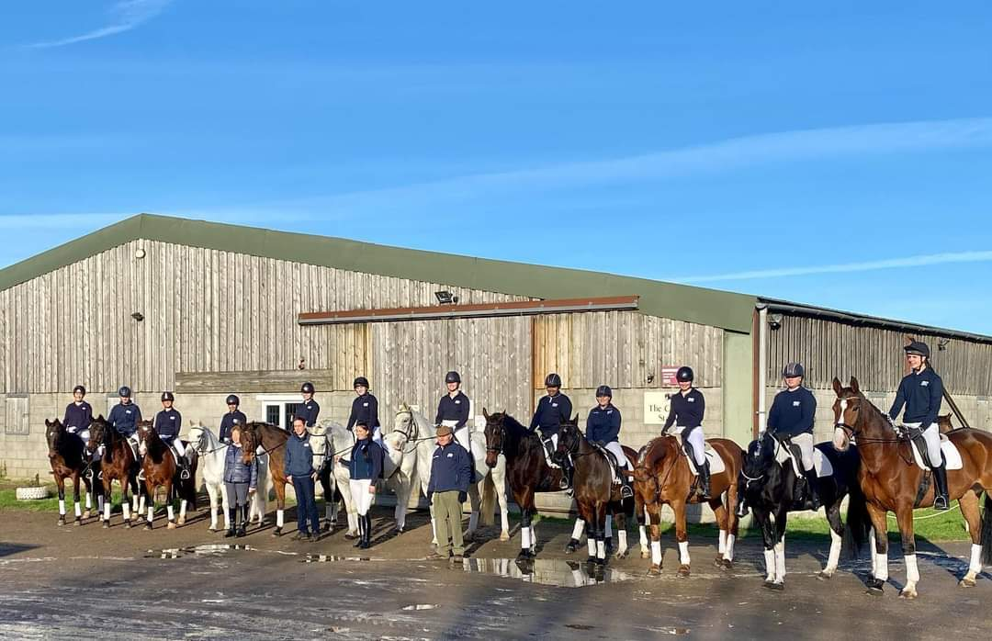

This year has been full of ups and downs on the yard
We have said a sad farewell to many of our old equine friends, but we have also been lucky to welcome some lovely new horses to the team, we would like to say a huge thank you to all the owners of our school horses for entrusting us with their horses.
Lockdown was a strange time for us all, but we took lots of positives from it, it gave us more time to do ‘those jobs’ we don’t get chance to do like painting the show jumps, spring cleaning the whole yard it also gave the horses a well-earned break.
We are incredibly proud of all our students this year they have worked awfully hard
Lockdown gave them the chance to try things they would not normally have had the chance to try such as,
Dressage to music , Advanced dressage test, Side saddle, and jump training through both lockdown’s with Brian, just to name just a few things they did!
It also gave us the chance to give them more training towards their exams
We have had 100% pass rate this year with their BHS exams ranging from stage 1 through to stage 5 (BHSI) riding and coach

Megan has been with us for over a year, she has completed all her exams up to her BHS Stage 3 Care. “ After the first lockdown I took Shannon out and managed to complete our first elementary test and we won! At Talland I have ridden my first pirouettes, lines of changes, not forgetting piaffe and passage! I now have the mindset that I can achieve anything I put my mind too”.

Billy came to Talland only expecting to stay for a few months, he has now been here a year and is continuing to train with us. Billy has achieved his complete Stage 3 and his Stage 4 ride. ‘ All of my achievements are down to the whole Talland Team with a special shoutout to Pammy, Brian and Claire, I have had fun competing Pammy’s 6yo Ebony and qualifying her for the regionals (with lots of help from Pammy who has probably been wanting to pull her hair out)!’

Anastasia arrived with us 2 weeks prior to the first lockdown in 2020, since arriving Anastasia has completed her BHS stage 1 and Ride and Road Safety exam (even with breaking her ankle mid-way through the year)! “Lockdown brought so many exciting opportunities including riding side saddle, drill rides, dressage to music, fun quizzes and the clap for the NHS videos. Also, right after the lockdown ended, I went cross country for the first time on the lovely Hobbs!”

Sarah came to Talland to train for her Stage 4 (she has now passed her Stage 4 management, care, lunge, and ride) “Abira was one of the most incredible horses I have had the privilege of riding, with Pammy’s dedication and Abira I learned and achieved many things I never thought I could have!’

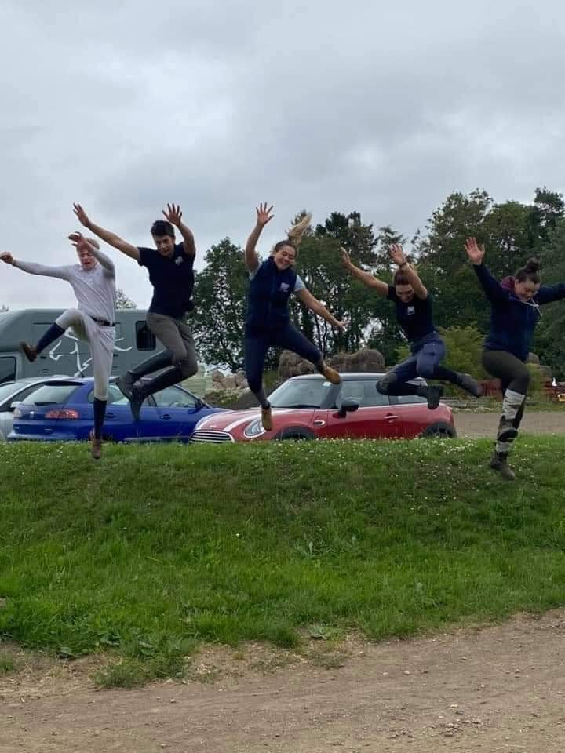
Olivia managed to pull many positives out of her year at Talland in 2020, she has managed to achieve her Stage 3 coaching exam and took her horse Kenco out competing (finally making it down the centre line). ‘This year we learned how to cut hair (not very well), we filmed our Christmas Demo and I got to ride Pammy’s horse Belmondo and he taught me everything from changes to pirouettes.’

Beth has completed her BHS Stage 4 care this year and is hoping to complete her BHS Stage 5 in 2021. “During lockdown we held in house competitions which gave us all the opportunity to ride in a competitive way to improve our abilities of riding under pressure, unfortunately my horse went lame, but I was given the opportunity to ride one of Pippa’s horses Kyra”.

Lucy only came to Talland in September, in this short amount of time Lucy has completed her Stage 1 Ride and Care and her first aid qualification. “Since being at Talland my riding has improved massively as well as my horse’s way of going, I can’t wait for 2021 at Talland o see how much more I can improve and learn”!

Joel came to Talland 1 week prior to the first lockdown and within the week he made the decision to stay “Since coming to Talland I have become a different person and a different rider for the better, I have been given potential and the motivation to work towards serious opportunities in the horse industry”.

Evie has completed her full Stage 3, Stage 4 Ride and First aid in just 8 months! “Next year I am hoping to complete my BHS stage 4 and with the help of Pammy and the whole Talland team I hope to campaign for the young riders eventing Europeans next year on both horses”.

Raunaq has had a busy year achieving his BHS Stage 5, Stage 4 care, and his HGV theory. “We learnt so much at Talland this year from how to improve your riding to how to manage an equine business (which was all including in Pammy’s group lessons. We got lots of new opportunities during this tough time including riding through my first PSG”.

Patryk has had an exciting year, passing 2 exams in 2 months this included his BHS Stage 2 Teach. ‘This year I had the opportunity to ride the schoolmasters, ride dressage to Music which was fun, and a new experience and I drank British Tea for the first time!’

Holly has now been at Talland for 2months, she arrived not having much experience as she has only been riding for the last year. ‘I feel that Talland has helped me see what my future has in store and helped me believe that I can achieve anything I put my mind too.’

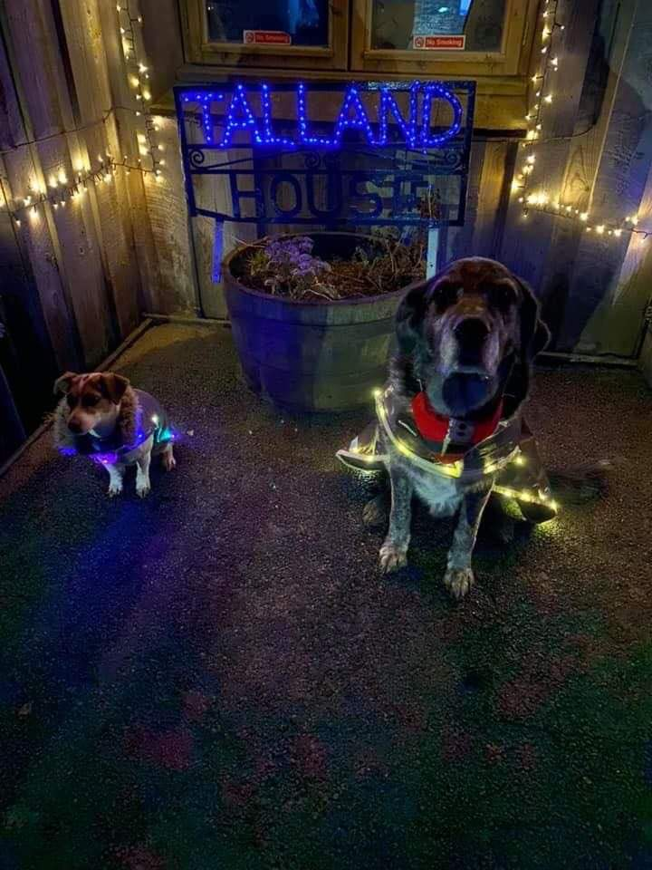

We would like to say a massive thank you too all our suppliers, clients, and supporters.

We all hope that life will return to some resemblance of normality, meanwhile we wish you a Merry Christmas and a Healthy 2021.

Gift vouchers are still available to purchase from the office until Christmas Eve, we will be back open on the 27th December.

